1. Evidence of API operation:
2. Creating a virtual environment:

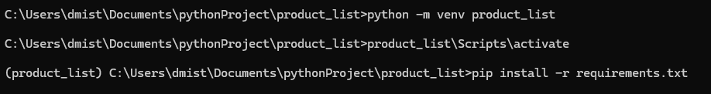

1. Installing requirements

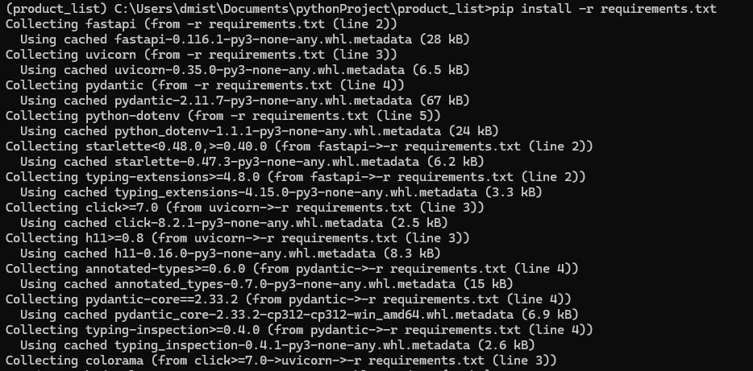

1. Starting API:

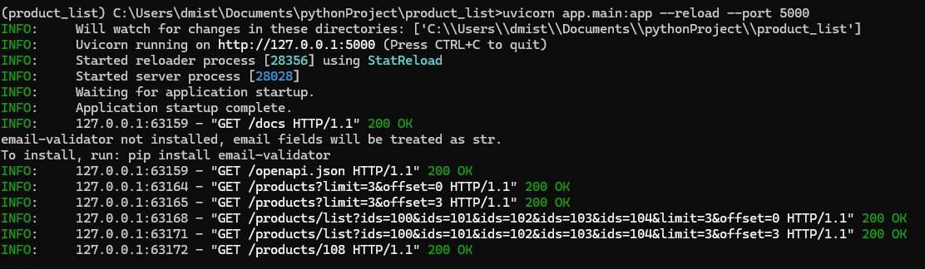

1. Accessing Interface/Swagger for API interaction:



1. Entering the authorization key for using the API (.env file):

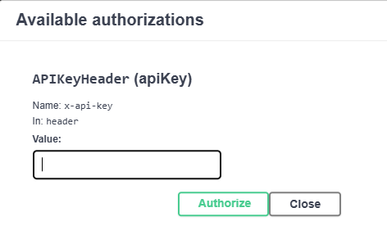

1. Interacting with API functions:

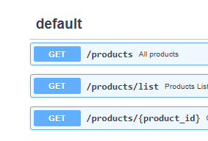

1. Searching for all products using return limit per pagination:

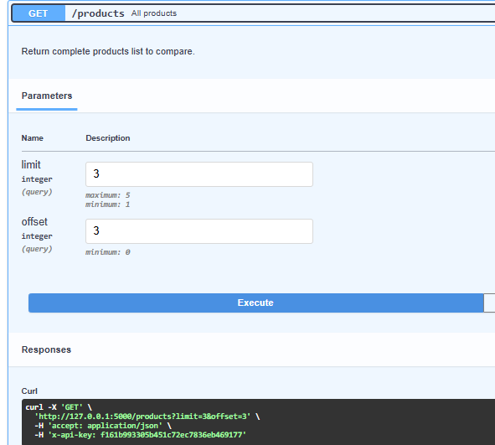

1. Return:

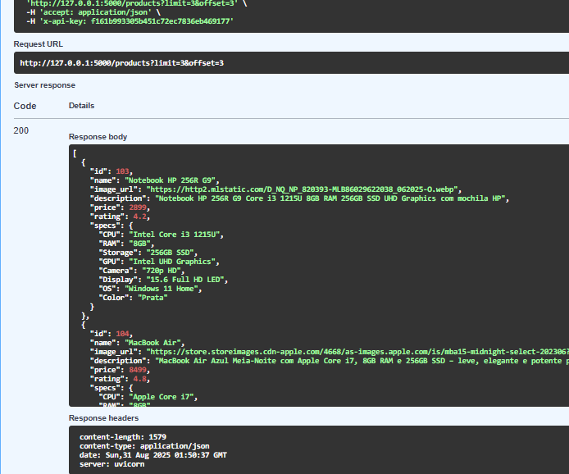

1. Query passing list of IDs with product limit per pagination:

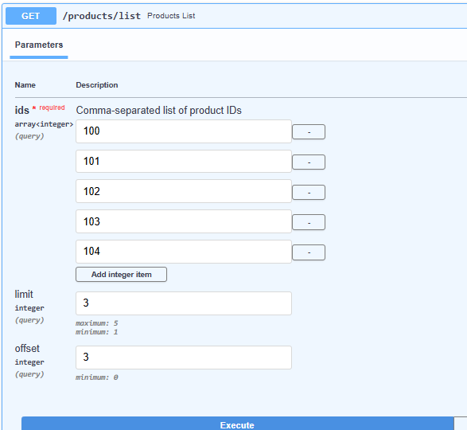

1. Product query by ID

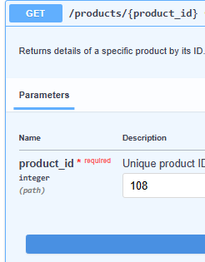

1. Content return:

